Aggregate expenditure

- Aggregate expenditure is the sum of all expenditure on final goods and services undertaken in the economy during a specific time period
- It consists of consumption (household expenditure on final goods and services); investment (spending on capital equipment); government spending and net exports (exports minus imports)
- Aggregate expenditure (AE) can be expressed using an equation:

$$AE=C+I+G+(X-M)$$

The components of aggregate expenditure

Component |  | Description
Consumption | C | Expenditure on non-durable goods – food, clothing, petrol  Expenditure on consumer durables – whitegoods, furniture, motor vehicles  Expenditure on services – doctors, plumbers, mechanics
Planned investment | Ip | Planned business expenditure on new capital equipment – machines, factories, building, tools  Expenditure on new housing
Government | G | G1: current (consumption) expenditure which are part of the day-to-day functions of government  G2: capital (investment) expenditure to provide for future needs such as school, roads, power, communications (infrastructure)
Net exports | X – M | Exports minus imports (trading of goods, services and financial transactions)

The Keynesian aggregate expenditure model

- To analyse the impact of changes in aggregate expenditure on economic activity we introduce the Keynesian expenditure model, based on the work of British economist john Maynard Keynes – Keynes developed his theory of aggregate expenditure in the 1930s, in the midst of the Great Depression

The consumption function

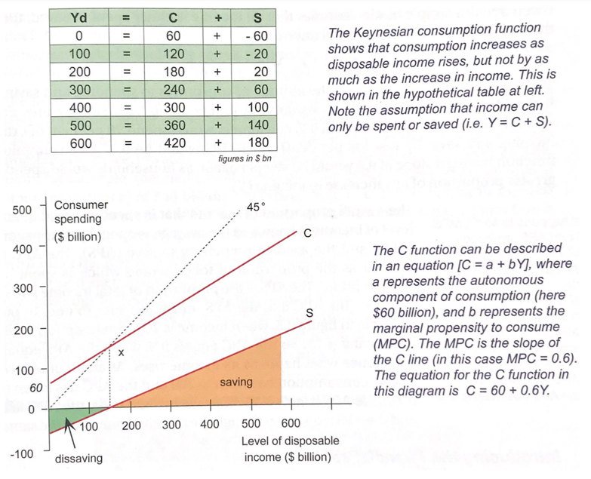
- The Keynesian expenditure model is based on the relationship between the level of disposable income received by households (Yd), and the level of consumption and saving – called the consumption function
- Initially it is assumed that there is no government sector and no overseas sector, so there are only two possible ways that people can use their Yd:
$$Y=C+S$$
$$Y=C+S$$

- Y represents income, C represents consumption and S represents savings
- A hypothetical consumption function for the economy is illustrated in the diagram, showing planned levels of consumption and savings expenditure at each level of income
- The level of spending on C and S is show on the vertical axis, and the disposable income is shown on the horizontal axis
- The 45° line is equidistant between the two axes, and thus shows all possible points where planned expenditure is equal to total income
- When the consumption function intersects the 45° line, the economy is in ‘equilibrium’, meaning that the level of income, output and spending (economic activity) in the economy is in balance and is stable
- At point ‘x’ the total level of consumption expenditure is $150 billion, which equals the level of income – this is referred to as the breakeven point
- At levels of income greater than $150 billion, consumption is less than income which means that saving is positive – for example, at a Y level of $300 billion, consumption equals $240 billion and saving equals $60 billion, and at a low level of Y such as $100 billion, consumption exceeds income at $120 billion, which means that savings is negative and referred to as dissaving
- The consumption function can be expressed as a linear equation:

$$C=a+bY$$

- The right hand side of the equation has two parts, including the variable ‘a’, being the vertical intercept (when the consumption function meets the y-axis) which is described as autonomous consumption (there would be some level of AS even if consumers had no income), and the second part of the right hand side, being the variable ‘b’, is the rate at which consumption (C) changes when income (Y) rises (the slope of the line)
- In the diagram, the equation for the consumption function is C = 60 + 0.6Y – this means that if income was zero, the autonomous level of consumption for the economy would be $60 billion, and for every $1 increase in Yd, households will spend 60 cents and save 40 cents
- This fraction (C = 0.6Y) is known as the marginal propensity to consume (MPC), and the MPC is the fraction of any change in income that is spent on consumption:

$$MPC= \frac{∆C}{∆Y}$$

- The fraction for any change in income that is saved is known as the marginal propensity to save (MPS), and in the example above the MPS is 0.4
- The MPS is the change in savings divided by the change in income:

$$MPS= \frac{∆S}{∆Y}$$

- Given that the simple model assumes that all income Is either spent or saved, then the MPC and MPS must add to equal 1
$$MPS+MPC=1$$

- The size of the MPC depends on the attitude of consumers to spending and saving – if the MPC increases, then the consumption function would be a steeper line
- The overall proportion of income that is spent or saved at any level of income is known as the average propensity to consume (APC) and the average propensity to save (APS)
- The APC is defined as the proportion of total income which is spent on consumption and the APS is the proportion of total income which is saved, and the two must sum to 1
- For example, when income is 200, consumption is 180 and saving is 20, the APC equals 0.9 while the APS equals 0.1 – as income rises, e.g., to 400, consumption has risen to 300 and the APC has fallen to 0.75 and the APS has risen to 0.25, showing that even as income rises, the APC falls and the APS rises despite marginal rates staying the same

Introducing the financial sector

- The consumption function is the cornerstone of the Keynesian aggregate expenditure model – we can now relax the assumption that consumers can only spend or save their income
- The financial sector acts as an intermediary to channel the savings of households to firms who can draw on these funds to finance investment

The full aggregate expenditure model

- We can now relax the assumption that the economy has no government or overseas sectors, and the full AE model can be represented using the equation:

$$AE=C+I+G+(X-M)$$

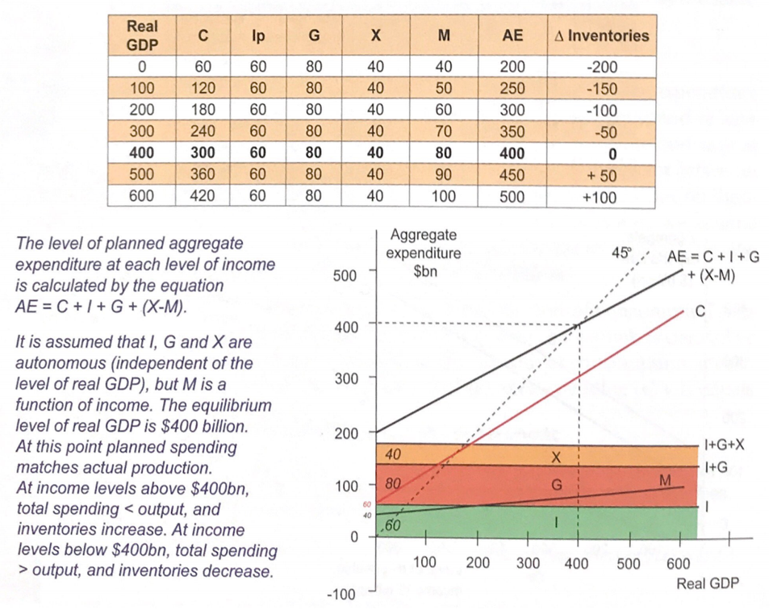
- Government expenditure (G) is assumed to be a fixed amount and independent of the real level of GDP (G = $80bn), and we make the same assumption for net exports (X-M) at $40bn (imports are assumed to increase with the level of Yd, in the example model, import spending increased by $10bn for each $100bn increase in GDP – MPT)
- The total amount of AE can be derived by adding the individual types of expenditure (C, Ip and G) and adding net exports (X-M), and in the example model, aggregate spending equals real GDP at $400bn, which is the equilibrium level of real GDP and all current production is sold, so there is no change in inventories
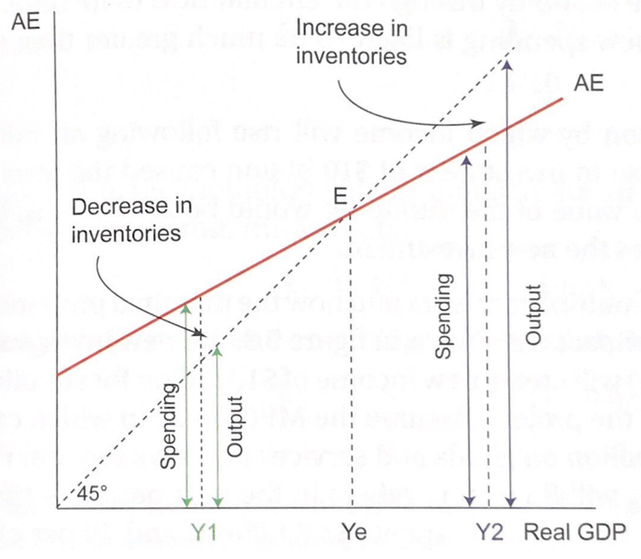
- At Y levels below $400bn, total spending > total output and inventories fall – firms respond by hiring additional resources to increase output to $400bn of goods and services, meaning there are no more unplanned changes in the level of inventories (equilibrium)
- At Y levels above $400bn, total spending < total output so inventories rise, causing firms to cut back production
- Macroeconomic equilibrium occurs when total planned spending equals total output, where the AE function crosses the 45 degree line – at point E, corresponding with the level of Ye

Changes in expenditure – the multiplier

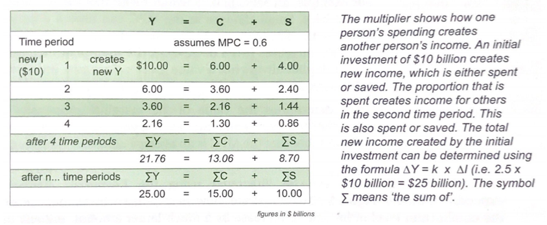
- Changes may occur in any of the components of aggregate expenditure, for example, the following events would result in a higher level of AE (the AE line in the model would shift upwards at all levels of Yd); a rise in retail spending due to an increase in consumer confidence, an increase in wheat exports, an increase in business investment associated with new clean energy projects
- To understand how such changes affect the rest of the economy, it is necessary to understand that new expenditure does not just have a once-off impact on the economy; any addition to (or reduction of) the level of spending in the economy will have far-reaching effects on aggregate levels of income, and the Keynesian theory described a model called the multiplier to explain this process
- There are a number of different formulas for the multiplier process, including:

$$k=\frac{1}{1-MPC} or k=\frac{1}{MPS} or \frac{1}{MPS+MPM+MPT}$$

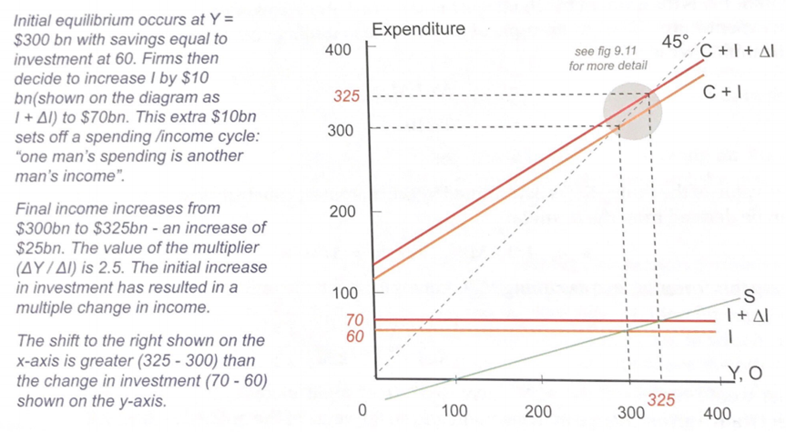
- Initially, we can assume that the economy has only three sectors including households, firms and the financial, so therefore, aggregate expenditure (AE) consists of consumption plus investment
- Assume a mining company decides to spend $10 billion to develop a main site and rail link in Western Australia – the initial (new) investment creates income for contractor firms and their employees, including engineers, architects and construction workers – these people will then spend part of that income of goods and services including food, clothing, rent and entertainment
- This spending will flow on to other people in the economy through the circular flow of income, and as a result, the final impact of the new spending is likely to be much greater than the initial value of the project
- The value of the MPC is dependent on attitudes to spending and saving and can change over time, as the MPC is an average across all households in the economy
- The multiplier refers to the proportion by which income will rise following an initial change in spending, for example, if an increase in investment of $10 billion caused by the level of income to rise by $25 billion, the value of the multiplier would be 2.5 (that is, the final impact income is 2.5 times the new investment)

The size of the multiplier
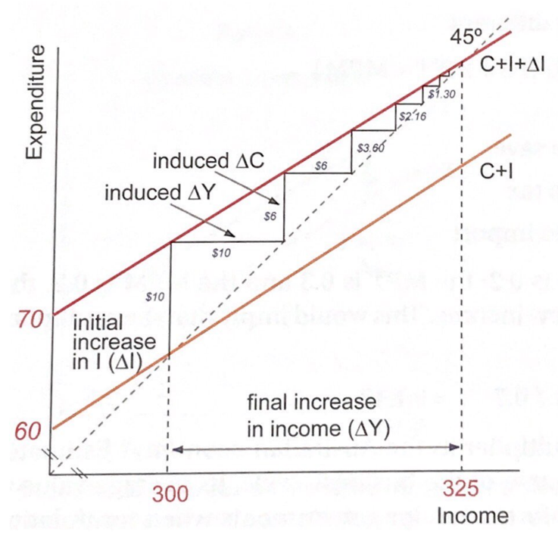
- The size of the multiplier is determined by the factors that affect the marginal propensity to consume (MPC) – if the MPC is greater than zero but less than one, the multiplier will have a value greater than one
- Is there an upper limit to the multiplier? – if the MPC was equal to one, then the multiplier would equal infinity – in reality, there are a number of factors which restrict the value of the MPC and therefore reduce the size of the multiplier
- The extent of the multiplier will be influenced by the size of leakages associated with savings, taxation and imports – each of these leakages reduced the size of the multiplier

Aggregate expenditure and the business cycle

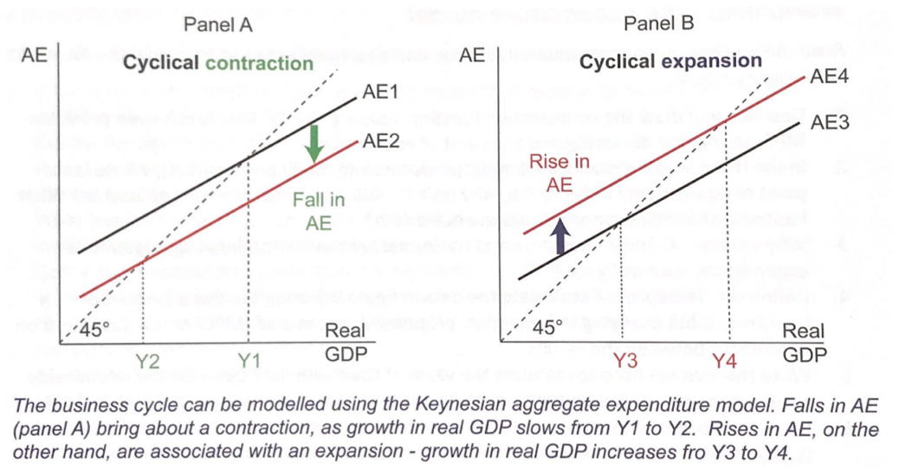
- The Keynesian aggregate expenditure model and the multiplier principle enable us to develop an understanding of the economic impact of changes in any of the components of aggregate expenditure – in general:
  - Any autonomous increase in one of the components of AE will be multiplied to result in a higher level of real GDP
  - Any autonomous decrease in a component of AE will be multiplied to result in a lower level of real GDP

